**Worksheet: Module 3**

CS 315: Data Structures and Algorithms

Richard S. Stansbury

Embry-Riddle Aeronautical University

Daytona Beach, FL

Student: Jeremiah Webb ID: 2545328

**Problem #1:**

Given the data: 3, 12, 44, 99, 72, 33, 11, 18, 65, 42

Sort the data and draw out a trace of the execution using ***Bubble Sort.***

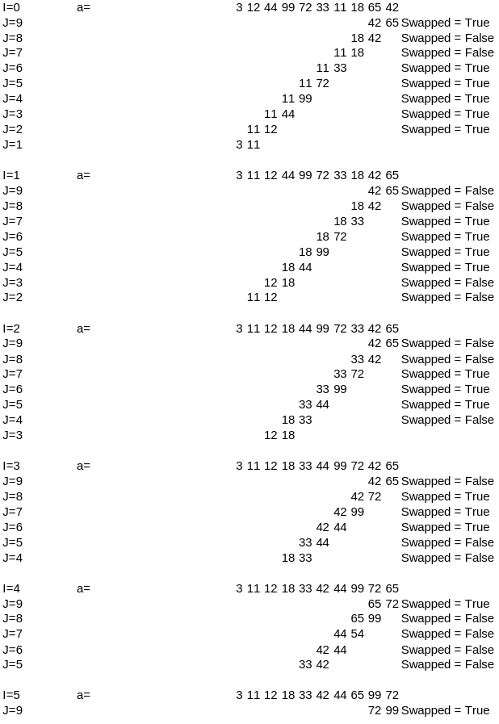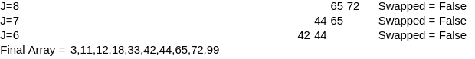

**Problem #2:**

Given the data: 8, 6, 42, 11, 5, 19, 88, 40, 9, 3

Sort the data and draw out a trace of the execution using ***Bubble Sort.***

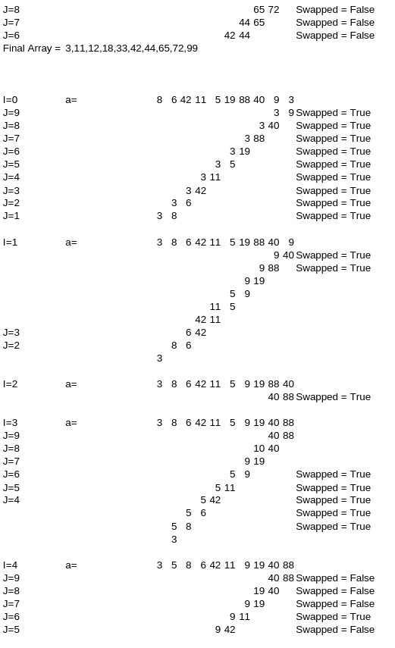

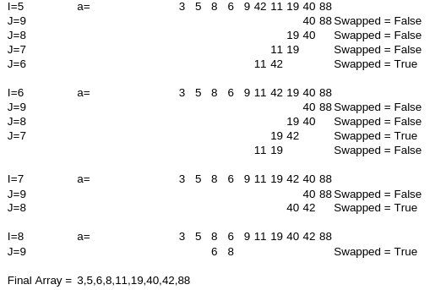

**Problem #3:**

Given the data: 3, 12, 44, 99, 72, 33, 11, 18, 65, 42

Sort the data and draw out a trace of the execution using ***Selection Sort.***

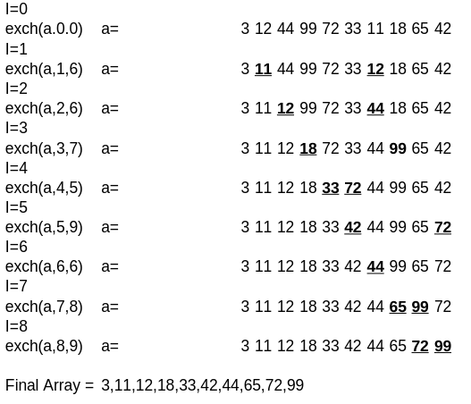

**Problem #4:**

Given the data: 8, 6, 42, 11, 5, 19, 88, 40, 9, 3

Sort the data and draw out a trace of the execution using ***Selection Sort.***

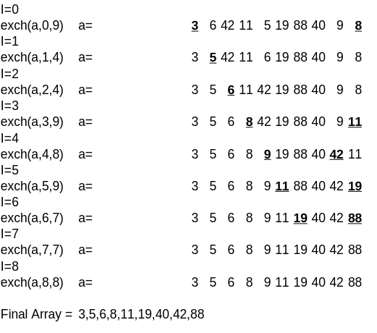

**Problem #5:**

Given the data: 3, 12, 44, 99, 72, 33, 11, 18, 65, 42

Sort the data and draw out a trace of the execution using ***Insertion Sort.***

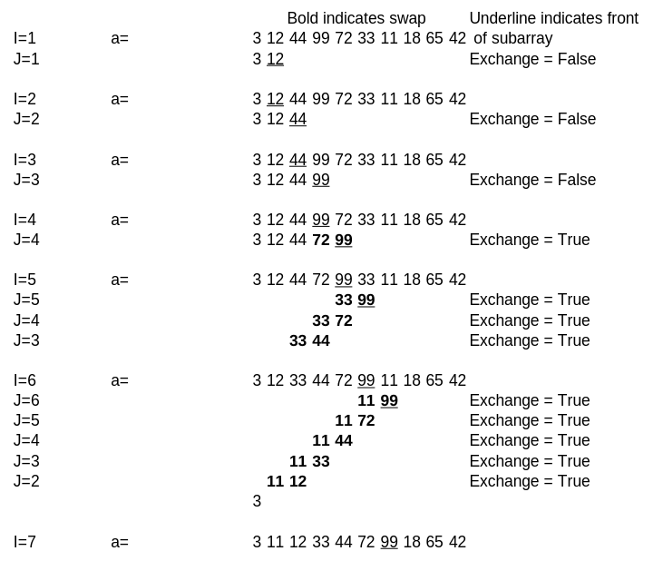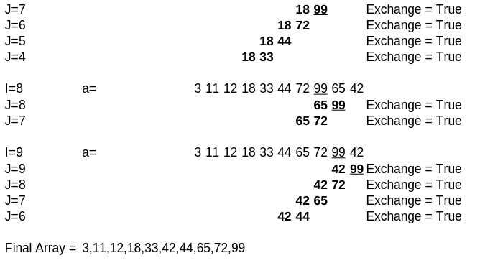

**Problem #6:**

Given the data: 8, 6, 42, 11, 5, 19, 88, 40, 9, 3

Sort the data and draw out a trace of the execution using ***Insertion Sort.***

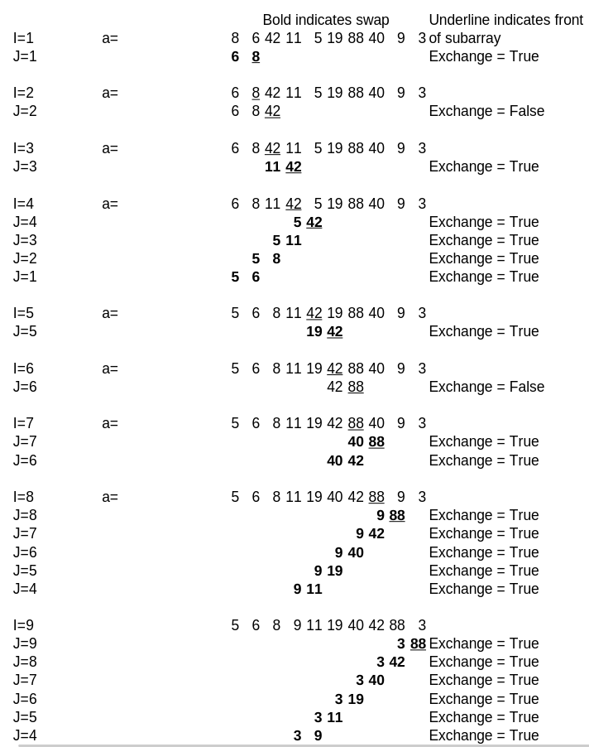

Final Array = 3,5,6,8,9,19,40,42,88